**Design Hierarchy:**

**The Elements of art:**

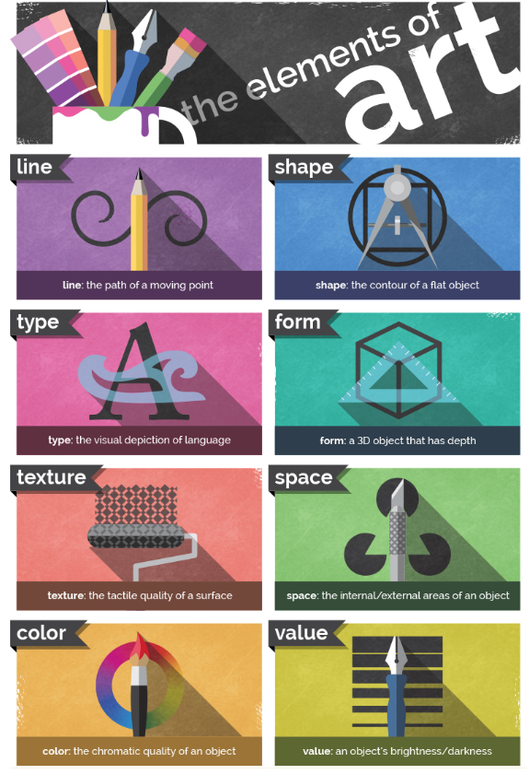

**The principles of design:**

